AWS EC2 Nginx Web Hosting Project
1. Project Title
AWS EC2 Virtual Machine Setup and Website Hosting Using Nginx
2. Objective
The objective of this project was to learn how to deploy and host a website on a cloud-based virtual machine using Amazon Web Services (AWS). The project involved creating an EC2 instance, configuring a Linux server, installing the Nginx web server, and hosting a static webpage.
3. Introduction
Cloud computing allows users to deploy applications and websites without maintaining physical hardware. Amazon Elastic Compute Cloud (EC2) is a web service that provides scalable virtual servers in the cloud.
In this project, an EC2 instance was launched and configured to host a simple static website using the Nginx web server. The website was created using HTML and deployed directly on the Linux server.
4. Tools and Technologies Used
- Amazon Web Services (AWS)
- Amazon EC2
- Linux Server
- Nginx Web Server
- HTML
- SSH
- GitHub
5. Implementation Steps
Step 1: Launch EC2 Instance
- Logged into AWS Management Console.
- Navigated to EC2 Dashboard.
- Created a new EC2 instance.
- Selected a Linux-based Amazon Machine Image (AMI).
- Configured security groups to allow SSH and HTTP traffic.
Step 2: Connect to the Instance
- Downloaded the key pair file.
- Connected to the EC2 instance using SSH.
- Verified successful access to the Linux terminal.
Step 3: Install Nginx
- Updated system packages.
- Installed the Nginx web server.
- Started and enabled the Nginx service.
Step 4: Create Website
- Created a simple HTML webpage using the Nano text editor.
- Saved the webpage in the Nginx web root directory.
Step 5: Host the Website
- Verified that Nginx was running successfully.
- Accessed the website using the EC2 instance's public IP address.
- Confirmed successful website deployment.
6. Project Outcome
The project was completed successfully. A static website was hosted on an AWS EC2 virtual machine using the Nginx web server. This project provided practical experience with cloud infrastructure, Linux server administration, and web hosting.
7. Skills Acquired
- AWS EC2 Management
- Linux Command Line Operations
- SSH Connectivity
- Nginx Configuration
- Website Deployment
- Cloud Computing Fundamentals
- GitHub Documentation
8. Screenshots
Screenshot 1: EC2 Instance Running
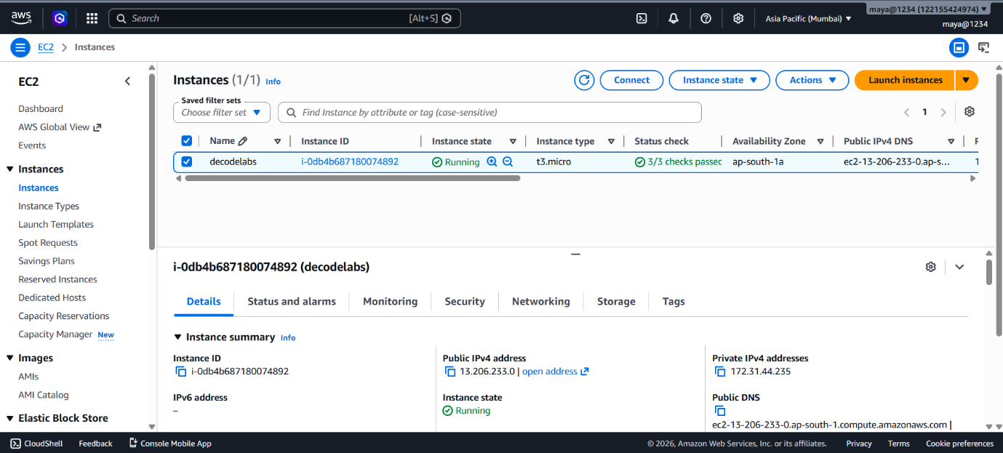

Screenshot 2: HTML File Configuration
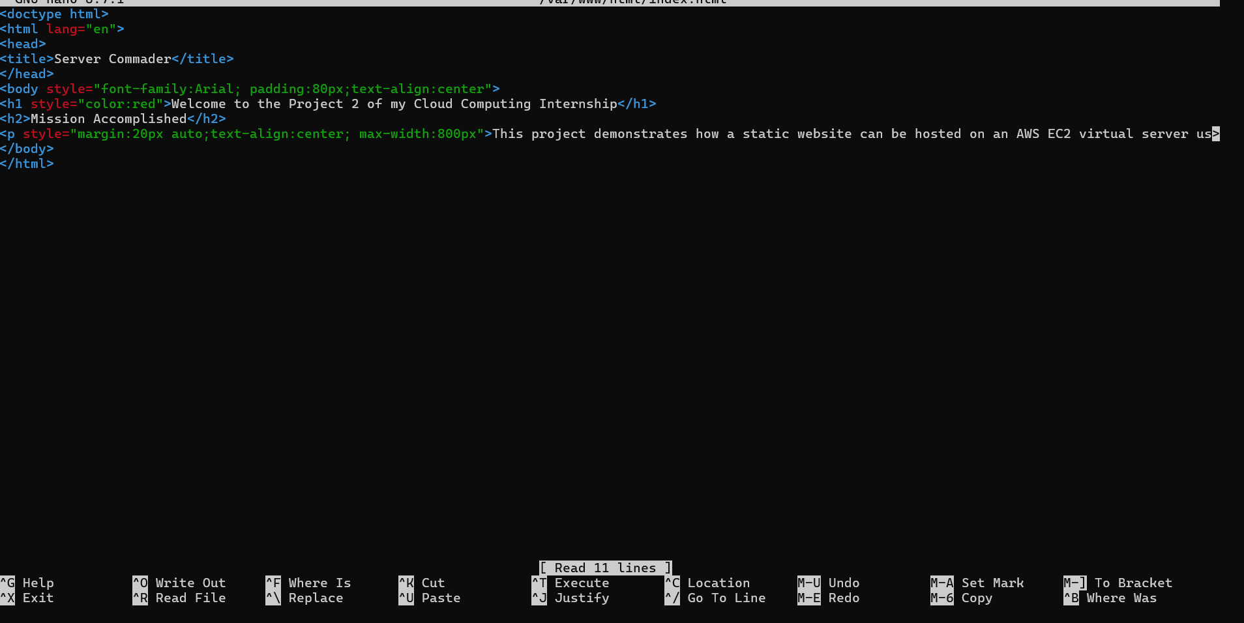
Screenshot 3: Website Successfully Hosted
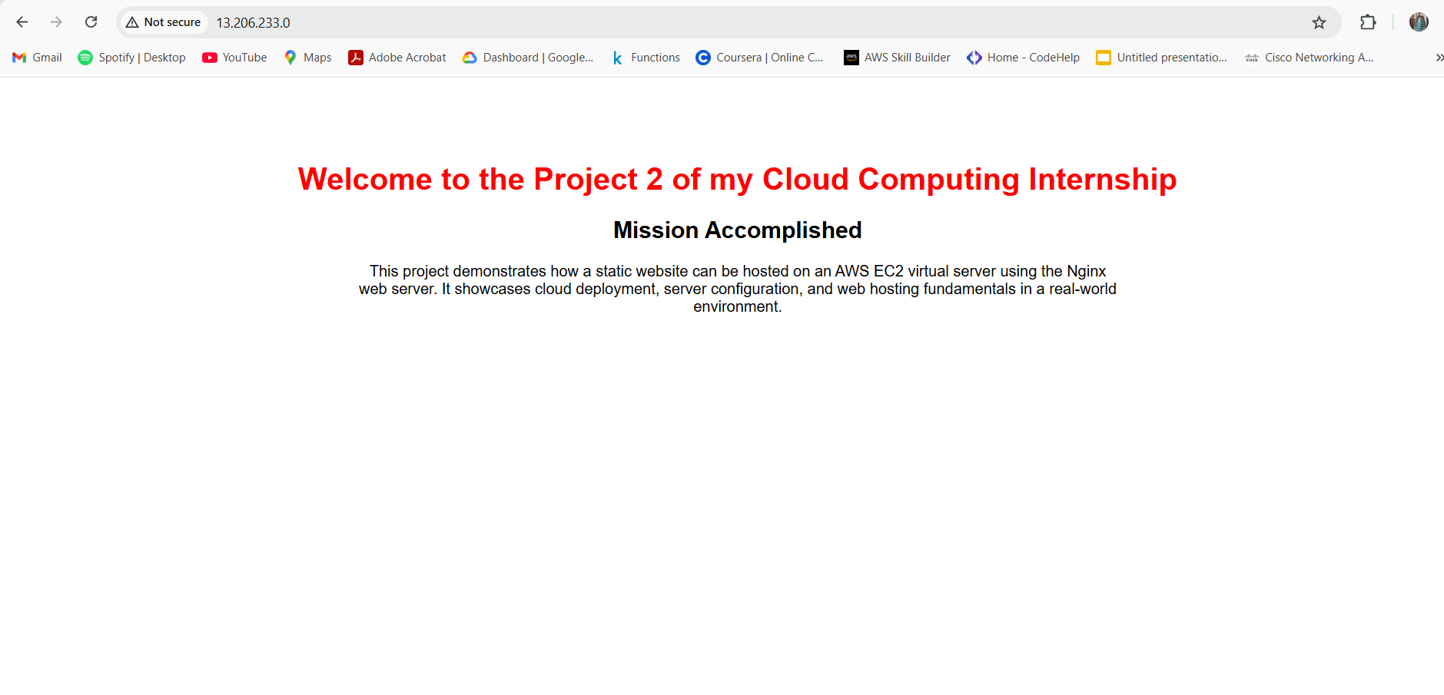
9. Conclusion
This project helped me understand the fundamentals of cloud computing and website hosting using AWS services. Through hands-on implementation, I learned how to create and manage virtual machines, configure web servers, and deploy websites in a cloud environment. The experience strengthened my practical knowledge of AWS and Linux administration.

